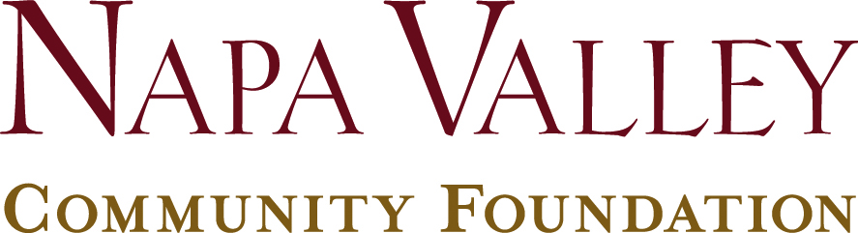

Investment Pool Worksheet

Napa Valley Community Foundation seeks to ensure that each Fund is invested in the pool that best matches the donor’s time horizon for distributions and philanthropic goals. Please visit this page of our website to see investment performance information about each pool below, or this page to see our Investment Policy.
Please indicate your investment pool recommendation based on your expected time horizon for distributions and philanthropic goals. You can change your investment recommendation once per year upon written request.

Annual Grant  Payout | Recommended  Investment Pool | Time Horizon for the Fund’s Assets
5% | Long Term Pool | Distributions over 5-10 or more years, creation of a permanent endowment or Legacy Fund
5% < x < 20% | Intermediate Term Pool | The Fund is likely to be expended within 1.5 to 5 years.
20%< x < 100% | Short Term Pool | The Fund is likely to be expended in less than 1.5 years.

_____% Long Term Pool _____% Intermediate Term Pool

_____% Short Term Pool

Please note: Any additional gifts to your Fund will be allocated according to the pools recommended above, unless otherwise requested in writing.

Name of Fund: ___________________________________________Date:_________

Donor Signature(s):_____________________________________________________

Foundation Staff Signature_______________________________________________

